**Experiment - 1**

**AIM:** To Study the Types of Networks & Networking Devices.

**Types of Network**

In the today world, two devices are in network if a process in one device is able to exchange [information](http://ecomputernotes.com/fundamental/information-technology/what-do-you-mean-by-data-and-information) with a process in another device. Networks are known as a medium of connections between nodes (set of devices) or computers. A network is consist of group of [computer](http://ecomputernotes.com/fundamental/introduction-to-computer/what-is-computer) systems, servers, networking devices are linked together to share resources, including a [printer](http://ecomputernotes.com/fundamental/input-output-and-memory/what-is-a-printer-and-what-are-the-different-types-of-printers) or a file server. The connections are established by using either cable media or wireless media. The Network allows computers to connect and communicate with different computers via any medium.

LAN, MAN and WAN are the three major types of the network designed to operate over the area they cover. There are some similarities and dissimilarities between them. One of the major differences is the geographical area they cover, i.e. LAN covers the smallest area; MAN covers an area larger than LAN and WAN comprises the largest of all.

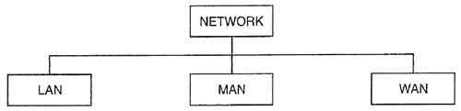

1. **Local Area Network (LAN):**

A [LAN](https://www.lifewire.com/local-area-network-816382) connects network devices over a relatively short distance. A networked office building, school, or home usually contains a single LAN, though sometimes one building will contain a few small LANs (perhaps one per room), and occasionally a LAN will span a group of nearby buildings. In TCP/IP networking, a LAN is often but not always implemented as a single IP [subnet](https://www.lifewire.com/what-is-subnet-818392).

In addition to operating in a limited space, LANs are also typically owned, controlled, and managed by a single person or organization. They also tend to use certain connectivity technologies, primarily [Ethernet](https://www.lifewire.com/what-is-ethernet-3426740) and [Token Ring](https://www.lifewire.com/what-is-token-ring-817952).

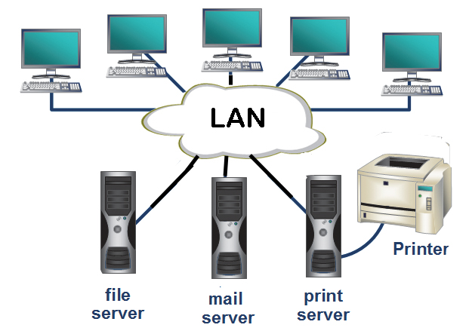

1. **Metropolitan Area Network (MAN):**

MAN or Metropolitan Area Network covers a larger area than that of a LAN and smaller area as compared to WAN. It connects two or more computers that are apart but resides in the same or different cities. It covers a large geographical area and may serve as an ISP (Internet Service Provider). MAN is designed for customers who need a high-speed connectivity. Speeds of MAN ranges in terms of Mbps. It’s hard to design and maintain a Metropolitan Area Network.

The fault tolerance of a MAN is less and also there is more congestion in the network. It is costly and may or may not be owned by a single organization. The data transfer rate and the propagation delay of MAN is moderate. Devices used for transmission of data through MAN are: Modem and Wire/Cable. Examples of a MAN are the part of the telephone company network that can provide a high-speed DSL line to the customer or the cable TV network in a city.

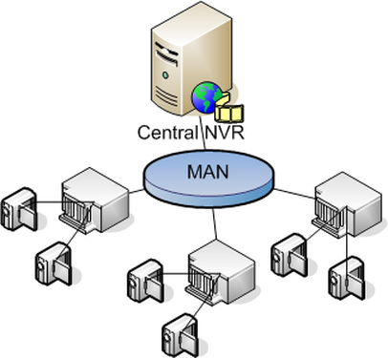

1. **Wide Area Network (WAN):**

As the term implies, a [WAN](https://www.lifewire.com/wide-area-network-816383) spans a large physical distance. The Internet is the largest WAN, spanning the Earth.

A WAN is a geographically-dispersed collection of LANs. A network device called a [router](https://www.lifewire.com/how-routers-work-816456) connects LANs to a WAN. In IP networking, the router maintains both a LAN address and a WAN address.

A WAN differs from a LAN in several important ways. Most WANs (like the Internet) are not owned by any one organization but rather exist under collective or distributed ownership and management. WANs tend to use technology like [ATM](https://www.lifewire.com/asynchronous-transfer-mode-817942), [Frame Relay](https://www.lifewire.com/definition-of-frame-relay-817947) and [X.25](https://www.lifewire.com/x-25-816286) for connectivity over the longer distances.

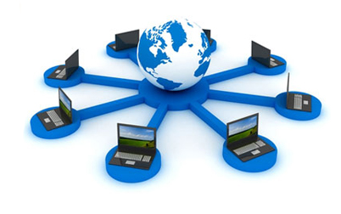

**Networking Devices**

Computer networking devices are known by different names such as networking devices, networking hardware, network equipment etc. However, all of the names mean the same but have got different purposes.

**Repeater**

A repeater is a network device that retransmits a received signal with more power and to an extended geographical or topological network boundary than what would be capable with the original signal.

A repeater is implemented in computer networks to expand the coverage area of the network, propagate a weak or broken signal and or service remote nodes. Repeaters amplify the received/input signal to a higher frequency domain so that it is reusable, scalable and available.

Repeaters are also known as signal boosters.

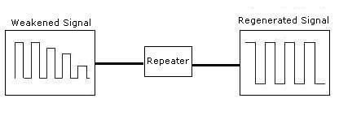

**Hub**

A hub, in the context of networking, is a hardware device that relays communication data. A hub sends data packets (frames) to all devices on a network, regardless of any MAC addresses contained in the data packet. This places a lot of traffic on the network and can lead to poor network response times. When a frame is received, it is amplified and then transmitted on to the port of all the connected PCs.

Hubs are considered to work at physical layer of OSI model.

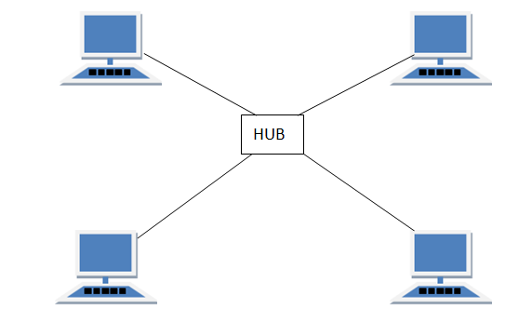

**Passive Hub:** Passive Hub does not require power as they do not regenerate the received signal before forwarding.

**Active Hub:** Regenerate the received signal before forwarding it to all the ports. So, the active hub needs a power supply. The small workgroup hubs normally use an external power adapter, but on larger units, the power supply is built in.

**Router**

Router is **Network layer (Layer 3)** of the OSI reference model device that means it can connect multiple computer networks via wired or wireless connections. Network router can receive, analyze, perform the traffic directing functions and forwards data packet from one network to its destination node. A router is a device that forwards packets between networks by processing the routing information included in the packet.

**Routers use logical and physical addressing to connect two or more logically separate networks.**

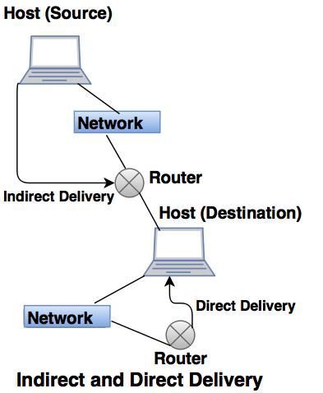

**Switch**

A switch, in the context of networking is a high-speed device that receives incoming data packets and redirects them to their destination on a local area network (LAN). A LAN switch operates at the data link layer (Layer 2) or the network layer of the OSI Model and, as such it can support all types of packet protocols. Switches are similar to hubs, only smarter.

A switch creates an electronic tunnel between source and destination ports for a split second that no other traffic can enter. Essentially, switches are the traffic cops of a simple local area network.

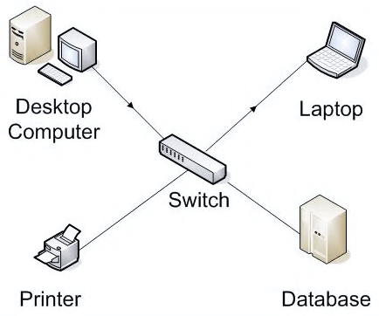

**Bridge**

A bridge operates at data link layer. A bridge is a repeater, with add on functionality of filtering content by reading the MAC addresses of source and destination. It is also used for interconnecting two LANs working on the same protocol. It has a single input and single output port, thus making it a 2 port device.

**Types of Bridges: -**

* **Transparent Bridges:-**These are the bridge in which the stations are completely unaware of the  
  bridge’s existence i.e. whether or not a bridge is added or deleted from the network , reconfiguration of  
  the stations is unnecessary. These bridges make use of two processes i.e. bridge forwarding and bridge learning.
* **Source Routing Bridges: -**In these bridges, routing operation is performed by source station and the frame specifies which route to follow. The hot can discover frame by sending a special frame called discovery frame, which spreads through the entire network using all possible paths to destination.

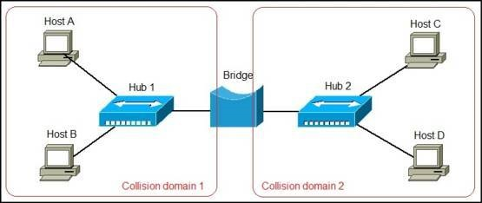

**Gateway**

A gateway, as the name suggests, is a passage to connect two networks together that may work upon different networking models. They basically work as the messenger agents that take data from one system, interpret it, and transfer it to another system. Gateways are also called protocol converters and can operate at any network layer. Gateways are generally more complex than switch or router.

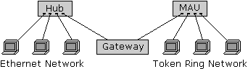

**Conclusion**

In conclusion, a network is two or more computers connected together using a telecommunication system for the purpose of communicating and sharing resources. Without having a network, Companies would not be able to share resources and increase productivity more effectively. The WAN network allowed companies to use the Internet over large areas. This provided the company tohave meetings overseas by video conferencing and sharing data over the network. As you can see, Networks have many benefits to the end user. Weather your Network is Wired or Wireless, Networks arean important part of technology.